Hong Kong Exchanges and Clearing Limited and The Stock Exchange of Hong Kong Limited take no responsibility for the contents of this announcement, make no representation as to its accuracy or completeness and expressly disclaim any liability whatsoever for any loss howsoever arising from or in reliance upon the whole or any part of the contents of this announcement.

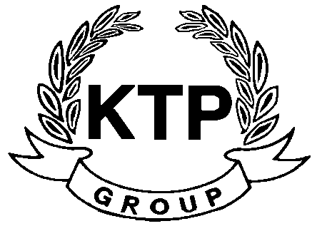
KTP HOLDINGS LIMITED
港台集團有限公司*
(Incorporated in Bermuda with limited liability)
(Stock Code: 645)

PROFIT WARNING

This announcement is made by the Company pursuant to Rule 13.09 of the Listing Rules.

The Board wishes to inform the Shareholders and potential investors that the Group is expected to record a significant decrease in the net profit attributable to Shareholders for the year ended 31st March 2011 as compared to the year ended 31st March 2010.

Shareholders and potential investors are advised to exercise caution when dealing in the shares of the Company.

This announcement is made by KTP Holdings Limited (the “Company”, and together with its subsidiaries, the “Group”) pursuant to Rule 13.09 of the Rules Governing the Listing of Securities on The Stock Exchange of Hong Kong Limited (the “Listing Rules”).

The board of directors of the Company (the “Board”) wishes to inform the shareholders of the Company (the “Shareholders”) and potential investors that the Group is expected to record a significant decrease in the net profit attributable to Shareholders for the year ended 31st March 2011 as compared to the year ended 31st March 2010. Based on the information currently available, the Board considers that the decrease is mainly due to the absence of one-off gain from disposal of subsidiaries which were recorded in the last corresponding year.

The Company is still in the process of finalising the Group’s annual audited results for the year ended 31st March 2011. The information contained in this announcement is only based on the Company’s preliminary review of the management accounts of the Group, which have not been audited or reviewed by the Company’s auditors. Further details of the Group’s performance will be disclosed in the Group’s annual audited results for the year ended 31st March 2011 to be announced before the end of June 2011.

Shareholders and potential investors are advised to exercise caution when dealing in the shares of the Company.

By Order of the Board
KTP Holdings Limited
Chua Chun Kay
Chairman

Hong Kong, 7th June 2011

As at the date of this announcement, the executive director of the Company is Mr. Chua Chun Kay (Chairman) and the independent non-executive directors are Mr. Yeung Kin Bond, Sydney Mr. Lam Pun Yuen, Frank and Mr. Ngan Hing Hon

*For identification purpose only

